# Compulsory Protocol for publishing the Network Rail Live Lift API data

Firstly, we are excited that you are interested in publishing Network Rail’s live lift API data! This information has been proven to drive an increase in quality of data for passengers, particularly with accessibility needs.

It is critically important that when consuming and displaying this data to the public**, the following protocol** is complied with to make this data easy for passengers to understand, and to ensure consistency among providers of this information.

This wording has been agreed with the National Rail Accessibility Panel and Rail Delivery Group.

Please visit <https://accessmap.nationalrail.co.uk/> to view a compliant example of how this information is displayed to the public.

Please note that at present, live data on escalators is very limited and multiple escalators will show that no live data is available. Network Rail is looking to address this in the future but *advise that escalator data should be excluded from displaying any data to passengers at present.*

**API Information Display Protocol**

1. **Please display the status for each lift using the following symbols and wording only:**

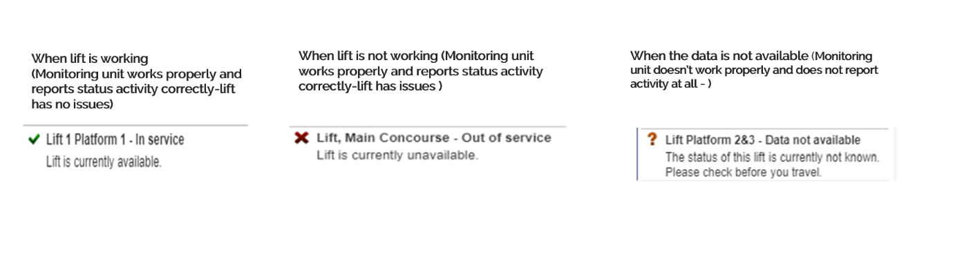

Display format:

Status situation:

Status situation:

Display format:

Figure

1. **Please ensure the following is noted when the information is also displayed along with live lift information:**

* “To replan, please visit National Rail Enquiries (NRE) [website](https://ojp.nationalrail.co.uk/service/planjourney/search) or call the NRE contact centre service to ensure that we enable your journey to continue. “
* “Not all stations with lifts are currently reporting live information as new technology is in the process of being rolled out.”

1. **Please ensure you only display the following information to the public – these criteria can all be filtered on the API to retrieve only data that meets these criteria:**

* In Commission lifts **(not escalators)**
* Customer facing lifts **(not escalators)**

**Example of query return and what should be displayed to the public:**

"blockId": "10866" – Do not display this field to public

"blockTitle": "Lancaster Stn Lift/Escalator 01", - Do not display this field to public

"alternateName": "Lift, Platform 4", - Display

"type": "Lift", - Display

"uprn": "147969000", - Do not display this field to public

"status": "Unknown", - Display

"operationalStatus": "Operational", - Do not display this field to public

"updatedTime": "2024-01-12T18:09:10.000Z", - Do not display this field to public

"customerFacingFlag": "true", - Do not display this field to public

"inCommissionFlag": true, - Do not display this field to public

"station": {

"name": "Lancaster Stn", - Display

"id": "02i4K00000FIGh5QAH", - Do not display this field to public

"crsCode": "LAN", - Display

"postCode": "LA1 5NW" - Do not display this field to public

},

"region": {

"id": "0Hh4K0000000XQTSA2",

"name": "North West & Central Region" - Do not display this field to public

},

"route": {

"id": "0Hh4K0000000XQYSA2",

"name": "North West Route" - Do not display this field to public

},

"toc": {

"id": "0014K00000bX7EcQAK",

"name": "Avanti West Coast TOC" - Do not display this field to public

},

"long": "-2.8072", - Do not display this field to public

"lat": "54.0488", - Do not display this field to public

"engineerOnSite": "false", - Do not display this field to public

"independent": "false", - Do not display this field to public

"isolated": "false", - Do not display this field to public

"sensorId": "8759", - Do not display this field to public

"timeToFix": null - Do not display this field to public

**Transport for London Lifts**

Note: some stations with lifts are not owned by Network Rail and therefore may not have live reporting of lifts. These include the following Transport for London stations where you can direct users to Transport for London for information on live availability rather than displaying this API information if no live data is available.

**Example:**

“There are TfL operated lifts at this station, but currently, no live data is available.  
Please check TfL webpages for lift status.”

**(Refer to Figure 1)**

|  |
| --- |
| **Station Name with TfL Operated Lifts** |
| Warwick Parkway |
| Princes Risborough PRR |
| Acton Main Line |
| Brockley |
| Bromley South |
| Brentwood |
| Burnham |
| Chadwell Heath |
| Caledonian Road & Barnsbury |
| Camden Road |
| Canonbury |
| Coulsdon South |
| Charlton |
| Carshalton |
| City Thameslink |
| Dalston Junction |
| Dartford |
| Deptford |
| Edmonton Green |
| Elstree & Borehamwood |
| Mitcham Eastfields |
| Forest Hill |
| Forest Gate |
| Gidea Park |
| Goodmayes |
| Gospel Oak |
| Hackney Central |
| Hackney Wick |
| Haggerston |
| Hanwell |
| Hayes & Harlington |
| Herne Hill |
| Hampstead Heath |
| Honor Oak Park |
| Hoxton |
| Harold Wood |
| Iver |
| Kensal Rise |
| Ilford |
| Langley |
| Manor Park |
| Maidenhead |
| Maryland |
| Orpington |
| Queens Road Peckham |
| Purley |
| Reading |
| Shenfield |
| Shoreditch High Street |
| Slough |
| Southall |
| St Mary Cray |
| South Tottenham |
| Seven Kings |
| Swanley |
| Taplow |
| Twyford |
| West Drayton |
| West Ealing |
| White Hart Lane |
| West Hampstead |
| West Hampstead Thameslink |
| Abbey Road |
| All Saints |
| Blackwall |
| Bow Church |
| Crossharbour |
| Custom House for ExCel |
| Deptford Bridge |
| Devons Road |
| East India |
| Gallions Reach |
| Heron Quays |
| Island Gardens |
| King George V |
| Langdon Park |
| Pontoon Dock |
| Poplar |
| Prince Regent |
| Pudding Mill Lane |
| Royal Albert |
| Royal Victoria |
| Stratford High Street |
| Stratford International |
| South Quay |
| Star Lane |
| Westferry |
| West India Quay |
| West Silvertown |
| Acton Town |
| Bromley-by-Bow |
| Bermondsey |
| Bond Street |
| Borough |
| Caledonian Road |
| Cockfosters |
| Debden |
| Earl's Court |
| Edgware |
| East Ham |
| Euston Square |
| Fulham Broadway |
| Finchley Central |
| Golders Green |
| Green Park |
| Hendon Central |
| Hillingdon |
| Hainault |
| Hounslow East |
| Hounslow West |
| Ickenham |
| Kilburn |
| Kingsbury |
| Morden |
| Mill Hill East |
| Newbury Park |
| North Greenwich |
| Oakwood |
| Osterley |
| Pinner |
| Southfields |
| Sudbury Hill |
| Southwark |
| Tottenham Court Road |
| Tower Hill |
| Wood Lane |
| Wimbledon Park |
| Wembley Park |
| Bank |
| Blackfriars |
| Blackhorse Road |
| Barking |
| Brixton |
| Canning Town |
| Canary Wharf |
| Clapham Junction |
| Cannon Street |
| Cutty Sark for Maritime Greenwich |
| Crystal Palace |
| East Croydon |
| Elephant & Castle |
| Finsbury Park |
| Greenford |
| Greenwich |
| Harrow-on-the-Hill |
| Heathrow Terminals 2 & 3 |
| Highbury & Islington |
| Hammersmith |
| Harrow & Wealdstone |
| Heathrow Terminal 4 |
| Heathrow Terminal 5 |
| Imperial Wharf |
| London Bridge |
| London City Airport |
| Limehouse |
| Liverpool Street |
| New Cross Gate |
| Paddington |
| Richmond |
| Shadwell |
| Shepherd's Bush |
| Stratford |
| Tower Gateway |
| Tottenham Hale |
| Upminster |
| Victoria |
| Vauxhall |
| Waterloo |
| West Brompton |
| West Ham |
| Watford Junction |
| Willesden Junctions |
| Wimbledon |
| Wembley Central |
| Westminster |
| Woolwich Arsenal |
| Canada Water |
| Farringdon |
| Ealing Broadway |
| Amersham |
| Moorgate |
| Whitechapel |
| Nine Elms |
| Battersea Power Station |
| Woolwich |
| Abbey Wood |
| Barbican |
| Romford |
| Barking Riverside |